EX NO: 4 | Configure SMTP and FTP protocols using Packet Tracer
DATE:
03\08\2

Objectives
(i) To configure and test email communication between networked devices using the SMTP protocol and verify successful message delivery through a mail server.
(ii) To configure and test file transfer operations between a client and a server using the FTP protocol and verify successful file upload and download.
Software/Apparatus required:
(i) Cisco Packet Tracer
(ii) End Devices (PCs)
(iii) Switches
(iv) Copper Straight-through Cable / Automatic Cable Selector
(v) Routers
(vi) Server (Email server or FTP Server)
Procedure
Objective 1: SMTP Protocol
1. Create the network topology using two PCs, switches, a router, and a server in Cisco Packet Tracer.
2. Configure the necessary network settings on all devices and ensure that the router interfaces are enabled.
3. Verify connectivity between the PCs and the server using the ping command. 4. Open the server configuration window and enable the SMTP and POP3 services. 5. Create email accounts for the users on the server by specifying usernames and passwords. 6. Open the Email application on each PC and configure the email account details, including the email address, username, password, and mail server information.
7. From the sender PC, compose a new email by entering the recipient’s email address, subject, and message content.
8. Click Send to transfer the email to the mail server using the SMTP protocol. 9. On the recipient PC, open the Email application and click Receive to retrieve the email from the server using the POP3 protocol.
10. Verify that the email is successfully received in the recipient’s inbox. 11. Repeat the process with different users, if required, to confirm successful email communication.
Objective 2: FTP Protocol
1. Create the network topology using PCs, switches, a router, and an FTP server. 2. Configure the network settings and verify connectivity between the client PC and the FTP server.
3. Enable the FTP service on the server and create the required files.
4. Open the Command Prompt on the client PC and connect to the FTP server using ftp <Server_IP_Address>.
5. Display the files available on the server using dir.
6. Download a file from the server using get sample.txt.
7. Verify the downloaded file using dir.
8. Upload a file from the client PC to the server using put report.txt.
9. Display the updated file list using dir.
10. Close the FTP session using quit.
11. Verify that the file transfer operation was completed successfully.
Network Diagram
Objective 1: SMTP Protocol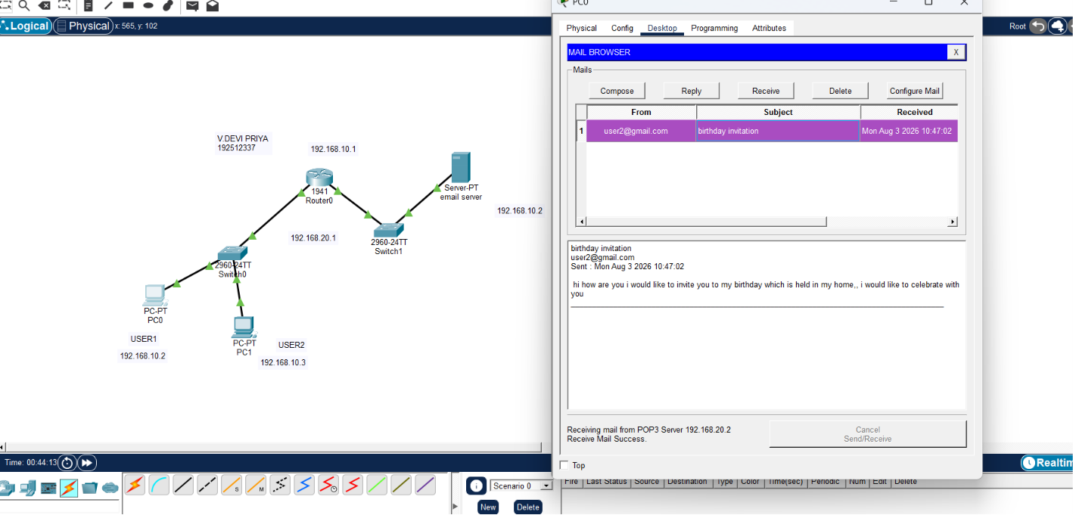
Objective 2: FTP Protocol
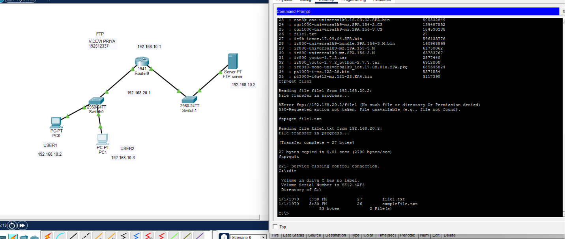
Output
Objective 1: SMTP protocol
From address | To address | Message
192.168.10.2 | 192.168.20.2 | Birthday invitation
192.168.10.3 | 192.168.20.2 | Summer vacation plan

Composed Email output
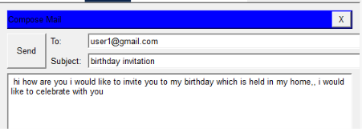Received Email output
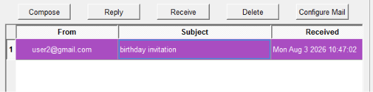
Objective 2: FTP protocol
Username 1 | Password 1 | Username 2 | Password 2 | File shared
DEVI | 2007 | DEVI | 2007 | File1
networks | 1010 | networks | 1010 | File_new1

Result
Objective 1: SMTP Protocol
(i) Email communication was successfully established, and email messages were transmitted and received correctly through the mail server using SMTP.
Objective 2: FTP Protocol
(ii) File transfer was successfully established, and files were uploaded to and downloaded from the FTP server using the FTP protocol.
Test case Question 1
Implement the specified SMTP topology using Cisco Packet Tracer and analyze email communication between client devices through a mail server.
Case 1
∙ Number of PCs: 2
∙ Number of Switches: 1
∙ Number of Routers: 1
∙ Number of Mail Servers: 1
∙ Services Enabled: SMTP and POP3
Case 2
∙ Number of PCs: 4
∙ Number of Switches: 2
∙ Number of Routers: 1
∙ Number of Mail Servers: 1
∙ Services Enabled: SMTP and POP3
∙ Inter-switch Connection: Switch-to-Switch Link
Tasks
1. Construct the specified topology and configure the mail server with SMTP and POP3 services.
2. Create email accounts for all users and configure the email clients on the PCs. 3. Send and receive email messages between users and verify successful email communication.
Aim  (10) | Networking  Diagram  (30) | Procedure (10) | Results (20) | Record  (10) | Viva  (20) | Total  (100)

Test case Question 2
Implement the specified FTP topology using Cisco Packet Tracer and analyze file transfer operations between client devices and an FTP server.
Case 1
∙ Number of PCs: 2
∙ Number of Switches: 1
∙ Number of Routers: 1
∙ Number of FTP Servers: 1
∙ File Transfer Mode: Client–Server
Case 2
∙ Number of PCs: 4
∙ Number of Switches: 2
∙ Number of Routers: 1
∙ Number of FTP Servers: 1
∙ File Transfer Mode: Client–Server
∙ Inter-switch Connection: Switch-to-Switch Link
Tasks
1. Construct the specified topology and configure the FTP server with user access and files. 2. Establish FTP connectivity between the client PCs and the server.
3. Perform file upload and download operations and verify successful file transfer.
Aim  (10) | Networking  Diagram  (30) | Procedure (10) | Results (20) | Record  (10) | Viva  (20) | Total  (100)

